Originator:
Name | Job Title | Signature | Date
Andrew Mason | Chief Technology Officer
Approvals:
Name | Job Title | Signature | Date
Brian Tompson | Engineering Consultant, Atego HighRely
Don Pegg | Engineering Consultant, PADT, Inc.
Andrea Miller | Quality Assurance Manager

- Purpose
The purpose of this document is to define the overall system requirements for the EPIC device firmware rewrite. The existing functionality in the firmware will be retained and some additional firmware functionality will be added.

- Scope
The scope consists of the EPIC device firmware as a whole, no other systems requirements are defined in this document.

- Definitions

PIC18F25J10-I/SS | The Microchip microcontroller that is being used in the project.  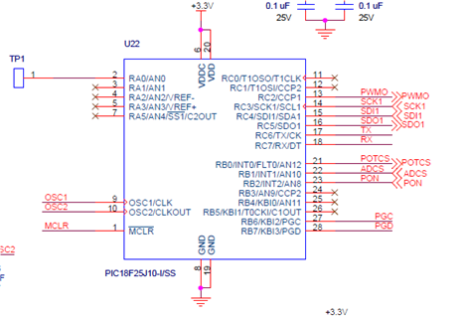

- System Requirements

Software Language
- [FRD_0001] All firmware should be rewritten in C, it is currently written in assembler.
PWM0
- [FRD_0003] Architecture timing will be based on hardware timers rather than the current implementation of using code execution timer.
- [FRD_0009] Enable the PWM0 signal frequency to be controlled by a host command. There will be multiple frequency settings.
- [FRD_0004] The pulse duty cycle should be fixed to 14uS.
- [FRD_0005] Enable the setting of the pulse voltage level through the use of a host command. Voltage level should be defaulted to a base level. The value specified for the voltage should be a % of the original value.
- [FRD_0006] Turn off power supply if Boost voltage is out of required range.
- [FRD_0007] Enable the setting of the pulse duration through the use of a host command.
- [FRD_0008] Add host command to control “Flood” LED output. The states are defined as on and off.
- [FRD_0011] Add a host command to initialize the pulse; this would start the pulse for the selected duration.
- [FRD_0010] Add a host command to stop the pulse duration before the predefined time has completed. If the duration was set to 30 seconds, sending this command before 30 seconds would stop the pulse.
- [FRD_0012] Separate the operation of the hardware from the flow of the software.
- [FRD_0013] Utilize watchdog timer to insure that the firmware properly recovers from unexpected errors.
- [FRD_0014] Implement two-way communications between the host computer and the device.
- [FRD_0024] Communication should always be initiated by the host, not by the device, except for the powerup information message.
- [FRD_0015] Implement a simple serial protocol to make the host communications more robust and modifiable.
- [FRD_0016] Implement a host command that will return the current settings of the device, including version number.
- [FRD_0025] Diagnostics mode will allow testing during the manufacturing process.

Document Revision History
Version Number: | Description of Change: | Date: | Updated by:
1.0 | Initial version | 12/15/10 | AFM
1.1 | Updated based on requirements review meeting.  Removed FRD_0002. | 12/15/10 | AFM
000 | Update FRD-004 to restrict the pulsed duty cycle to be fixed at 14s. Update FRD-0024 to exempt powerup information from the requirement to be initiated by the host. | 2/24/12 | A. Mason
001 | Update FRD-0016 to remove requirement for a checksum value in the current settings. |  | A. Mason

